This module is designed to give you a good basis on which to better understand the fisheries management practices used in Alberta, the fish which anglers target, and the equipment and techniques needed for a successful angling experience. For our purposes, people who engage in fishing will be referred to as “fishermen”, even though they may female.

Read the chapter on Fisheries Management in your textbook. If your kit doesn’t include a copy of the current fishing regulations of Alberta, obtain one from your teacher, or local license vendor.

**C:\Documents and Settings\Kelly.Lewis\Local Settings\Temporary Internet Files\Content.IE5\TL9T46E7\MC900230896[1].wmfWhat is fishing?**

In Alberta, fishing is considered either recreational or commercial. Recreational fishing is for fun and food, but the fish can't be sold. Commercial fishing is done with nets and the fish are sold either direct to consumers or to processing facilities. Managing the resource is required so there is enough fish for everyone and there will continue to be for generations to come. In most cases, limits are put on fish to ensure too many fish aren't taken from a given water body. However, some fish have no limits because they are not native to a water body, they are not desirable in a given water body, or the ecosystem needs to have them removed for continued survival of the ecosystem. Have a look at the following video and ask yourself the following questions: How could this have been prevented? Is there a better way to manage the situation? Is there anything like this happening in Alberta? Has it ever happened in Alberta?

Watch the video clip “Preventing a Hostile Takeover…” **(P1)**

This video, of course, isn’t set in Alberta, but it brings up the question – could it happen here?

It is obvious that there is a problem with Asian carp when you see them jumping out of the water and into the boat. It isn’t so easy to see what the status is of the other fish in a lake when they aren’t kind enough to jump into the boat and be counted. Fish numbers are obtained in several different ways and for several different purposes.

CREEL SURVEYS

A creel is an old-time fish basket that fishermen used to keep fish fresh and alive in the water after they had been caught. Creel surveys are taken at boat launches and docks on fish-bearing lakes to determine angler success, fish quantity and quality, and fishing pressure.

When fishermen arrive at a dock where creel surveys are being taken, they will be dealt with in one of two ways. The basic approach is asking the fishermen a few simple questions before allowing them to carry on. The more intensive survey may ask the fishermen to complete a survey, or allow the biologist to take measurements and samples of the fish.

Watch the videos on “Population Assessment”, “Egg Take” and “Warmwater Hatchery”.**(P2)**

This video is produced by the Minnesota Department of Natural Resources, but the processes and techniques they use are basically identical to the ones used in Alberta. Both Minnesota and Alberta have similar climatic conditions and many of the species of interest are the same in both places.

BIOLOGICAL DATA

C:\Program Files\Microsoft Office\MEDIA\CAGCAT10\j0305257.wmfWhen biologists gather information about a specific species of fish, they want to learn several things. From the time a fish is brought to hand (picked up), the biologist is gathering information. A quick visual inspection will tell the biologist the apparent health of the fish by looking at the color, condition of the fins, scales, eyes and mouth, any obvious disease or parasite infestation by patterns of damage on the fish, and whether the fish has adequate food sources by the condition of its belly.

Measuring the length of a fish and comparing it to the weight and age of the fish provides some interesting and important data. If a fish is small and healthy, but old, it tells the biologist that it is likely a lake where fish grow slowly. A fish which is large and healthy, but relatively young gives the biologist reason to suspect that fish grow quickly in that water body. The findings can often be corroborated with simple facts, such as temperature. Lakes that are cold and deep tend to let fish grow more slowly. There isn’t the warm shallows that create abundant food sources for the quick growth of fish, which explains why warm lakes can produce big fish. Lakes such as those attached to power plants keep conditions optimum for fish all year round and some power plant cooling ponds are the source of very large fish.

Sometimes biologists will take samples of fish and test them for a variety of chemicals and heavy metals. Lakes in agricultural areas will quite often catch run off from fields which have been sprayed or fertilized with a variety of chemicals. These chemicals can accumulate in fish and aquatic organisms, causing a variety of problems. In the same way, fish absorb heavy metals – such as mercury – and the levels build up in the fish over time. In both instances, the chemicals and heavy metals are transferred to organisms which eat the fish – such as ospreys, bears and humans – and cause a variety of devastating and potentially fatal conditions.

FISH HABITAT

There are some things that make a water body more suited to specific kinds of fish than others. Trout require moving water to carry out spawning. Lake trout need deep, cold water to survive. Sturgeon thrive in slow moving, murky water. Regardless of the species, there are things that they look for in a place to live. Unfortunately, civilization and man’s spread into natural areas has largely had a negative effect on fish habitat. Modifying stream and river banks has made clear water muddy which stops some fish from spawning. Building dams and weirs has affected traditional spawning patterns. Chemicals washing into water bodies from agricultural land, sewage and industrial waste has introduced harmful chemicals. Preserving fish habitat is something that everyone can be involved in.

Watch the videos “A Tale of Two Rivers” and “Urban Waterways” **(P3)**

Temperature is very important to fish survival and growth. Fish are cold blooded creatures which means they take on the temperature of the water they are in. Trout cannot survive in water above 24°C, whereas fish such as pike can survive in water as warm as 26°C. The temperatures that fish prefer to live in are well below the maximum temperatures. When water is shallow, the sun heats it quicker. Deep water will hold colder temperatures longer because water is a poor conductor of heat. This will explain why larger trout, such as lake trout, prefer to stay in deep cold water.

Fish need oxygen to survive, just like any living creature. However, instead of lungs, fish extract oxygen from the water using their gills. As the water flows through their mouths and over their gills, it is absorbed into their blood stream. Any damage done to a fish’s gills will usually prove fatal to the fish. The oxygen found in water is called dissolved oxygen. In the winter, most aquatic plants die and decompose, a process which consumes oxygen. If there isn’t enough oxygen in the water to support fish and the decomposition process, the fish will die. Water with depleted oxygen tends to go towards the bottom of the water column. Deep lakes can allow for plant decomposition and fish survival because there will still be enough oxygenated water at the top of the lake water for the fish to survive. When fish die as a result of lack of oxygen in the winter, it is referred to as “winter kill”.

The actual quality of the water is also important to fish survival. Water that contains dissolved minerals will become either acidic or alkaline. Most waters in Alberta tend towards the alkaline level. Fish prefer to live in waters that are neutral – a pH of 7 – but often survive in waters with a pH of 6 to 8.5. Waters with a pH level above or below this range will see very few fish surviving.

CONSERVATION VS PRESERVATION **(P4)**

There are two schools of thought when it comes to managing wildlife – conservation and preservation. Conservation focuses on managing a resource to ensure survival of a healthy population. Preservation is based upon allowing nature to take its course and not interfere through any management process. Alberta practices conservation at its highest form, ensuring that not only people will enjoy and benefit from utilizing the resource – for our interest, fishing – but the resource will continually replenish itself and be available for generations to come. Without management, resources can disappear in a hurry.

If a fishery is found to be damaged, or the fish numbers are not at the level that best suits the water body, restocking is a process often used to fix the situation. Restocking is simply replacing fish that have been taken out, lost for some reason, or if the fish population is not capable of replenishing itself. The majority of lakes in Alberta replenish themselves through management, but some fisheries aren’t capable of producing their own fish. These fisheries are often referred to as “stocked ponds” or “put and take” water bodies.

The strongest measure the government of Alberta has to best manage conservation of the province’s fisheries is through regulation. The goals of the regulation are not just to manage the number of fish caught, but also to ensure adequate time, space and conditions for reproduction are created. This includes the dates for fishing seasons which will allow spawning fish to carry out their spawning undisturbed by fishing pressures. It also deals with disturbing fish habitat. This extends from major acts, such as damming creeks and draining water bodies to building earthen docks and dredging beaches. Any activity which can affect fish populations in any way is regulated by the government.

There are three main types of fishing that the government deals with. Sport fishing, or angling, is done by individuals for enjoyment and personal use. Commercial fishing is done using nets with the goal of reselling the catch. Domestic fishing is done by aboriginal people through their treaty rights allowing them to catch fish for feeding their families. For our purposes, we will focus mainly on sport fishing.

REGULATIONS **(P5)** Read Ethical Behaviour and Legal Responsibilities in your text

j0250737.wmfSport fishing regulations are available where ever you purchase a license, and you will need to purchase a license if you are between the ages of 16 and 65.

The regulations are divided into several different sections. The most important one is the changes for the current season. Anyone who has fished in the past will have come to understand and expect certain rules and regulations. The changes section will introduce any changes from the previous year. The license and cost section outlines the cost of licenses, special licenses and license replacements. The regulations are divided into general regulations and regulations specific to fish management zones. It is important to check out any water body before you fish it to determine if it has special regulations in place. The fish management zones also list the legal land locations of various water bodies and the limits for fish in those places.

Quite simply, the regulations are in place to manage the resource. If people consistently ignore the regulations, the management can become vulnerable and some sections of the fisheries can be seriously damaged. Every person has an internal mechanism which dictates their reaction regulations and the way they treat them. This mechanism is called PERSONAL ETHICS.

Regulations cannot dictate a person’s ethics, but the way they are followed and spirit with which they are taken can be a very good indication of an individual’s understanding of management and their respect for the resource.

ETHICS

Ethics are standards of behavior or conduct which are considered to be morally right. A person develops their ethics as a result of their interpretation of the law, their upbringing and through careful consideration of all the information they may have.

An example of ethics is the attention paid to catch limits of fish. A person is allowed to take a certain number of fish on any given water body in the province. When they go fishing, they often take several children with them with the thinking that each person fishing is entitled to a limit of fish, so the total number of fish allowed in the boat is the limit times the number of people fishing. There are several ways a person can interpret this. One would be that everyone fishes until the maximum number is reached and fishing stops when it is reached, regardless of how many each person caught. The law would views it individually, so people adhering to the law would only keep their individual limit and not look at the whole boat limit. Yet another view would be looking at how many fish they really need to keep. They may feel the lake is heavily fished, so very few – if any – fish may be kept. They may feel that fish is best eaten fresh, so they only keep enough for a meal and stay under their limits. Ethics will determine who does what.

Respecting the views of others is also important. Some people do not support fishing, hunting, or any activity in which animals may be harmed. Everyone is entitled to an opinion or feeling and a true sportsman is considerate of those feelings. Some people are offended by the site of dead fish, or the remains of fish in public garbage cans. Ethical and understanding people keep their fish in containers until they are processed and then dispose of their remains discreetly in appropriate garbage containers. There are, however, people who make a big show of carrying stringers of fish through a campground, filleting them on picnic tables and leaving bits of blood, scales and fish slime. They will often dispose of the leftovers by tossing them in a garbage can where they attract flies, leave a bad smell and their sight could be disturbing to some people or small children. What type of fisherman would you like to be seen as?

PARTS OF A FISH

Most fish share the same parts, but some are particular to certain species. The salmonids posses an adipose fin. This small, fleshy fin on the back between the dorsal fin and caudal (tail) fin is often removed from trout and salmon which are raised in a hatchery and released in the wild as a means of identification.

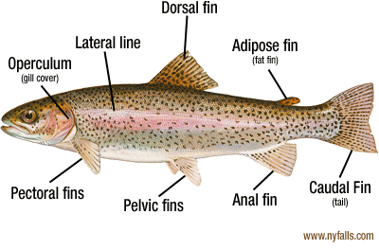

Fish, such as burbot, have fins which run basically the full length of the body from the anus to the tail on the bottom, and from the dorsal fin to the tail on the top.

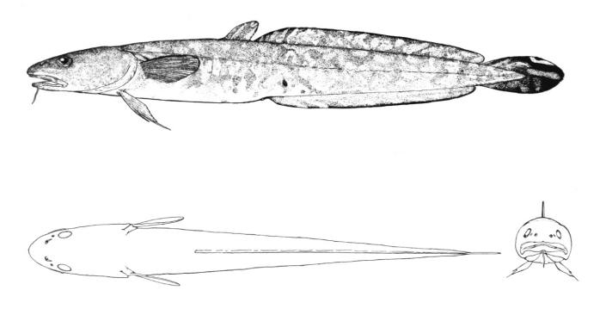

The same fish also has a barbell which looks like a single, long whisker under its chin. All fish, however, also posses a lateral line which allows the fish to sense movement in the water around it. It runs from the gill cover to the tail along the middle side of the fish.

FISH IDENTIFICATION **(P6)**

Fish can be grouped in several different ways. They can be classified by species (salmonids – trout, perchids – perch family, minnows), by the water they inhabit (cold water – mountain streams, cool water – streams & rivers, warm water – lakes), or by what they eat (fish eaters – perchids, insect eaters – trout, plant eaters – non in Alberta). The type of food a fish eats can help determine the place it holds in the food chain.

POPULAR GAME FISH Read the chapter in your text titled Game Fish Identification

Albertans love to fish. They don’t, however, focus on only a few species. Instead, there are only a few that aren’t being regularly targeted and that list is getting increasingly smaller. People fish for a few different reasons. Some like the challenge of catching the larger – and usually wiser – fish. Others catch them for the plate. Yet others find fishing a relaxing hobby and what they catch makes very little difference to them.

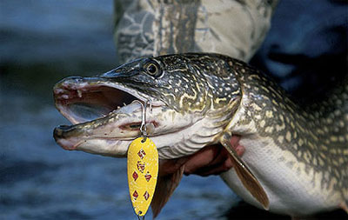It is difficult to determine the most sought after fish, but there are two that tend to be easier to catch – most of the time. Rainbow trout are commonly found around Alberta – but not because they are native to all waters. The rainbow is easily bred in captivity and transplant well into many water bodies. They are relatively easy to catch from shore or boat, and are good table fare. Wild populations of rainbows, however, are usually tougher to catch, but the size is often greater. Northern pike are also a common target species. They can survive in almost any water body and has a spectacular appetite. Pike have been known to eat everything from cutlery accidentally dropped over the side of a boat to frogs, baby ducks and muskrats. Their appetite makes them easy to catch on almost any lure with every possible presentation.

When it comes to eating, there is no clear cut winner. Many people rank the walleye as the number one fish for the table. However, cold water pike are an equally tasty creature. Some people swear by perch as the best for the table, and yet others say the burbot gives the whitest, flakiest, tastiest flesh out of all Alberta fish. Some people swear by goldeye when it comes to smoking and yet others go after suckers for canning. For the bar-b-que, it is hard to beat a big lake trout stuffed with lemons, but others will claim that when it comes to eating, baked whitefish is second to none. In any case, taking proper care of the fish after catching it is the most important step and will be examined later.

There are, however, two fish in Alberta that are illegal to keep. Bull trout and sturgeon have a limit of zero, which means if one is accidentally caught, it must be immediately released. Bull trout are the official fish of Alberta, but their numbers are declining. The way to identify bull trout has a catchy saying “no black, put it back” which means if there are no black markings on it and it is a trout, it must be returned to the water. Sturgeon are the dinosaur of Alberta fish. They are caught in the Red Deer River system and can live over 100 years and reach two metres or longer in length. Their numbers are also declining and keeping a sturgeon in Alberta is no longer legal.

FISHING EQUIPMENT AND TECHNIQUES (P7) Read Fishing Equipment & Techniques in your text

It doesn’t take much to go fishing. Every year, people catch lots of fish on very simple hook, line and rod combinations, which may actually be hook, string and stick. In the case of ice fishing, you only need a hook and line!!! We will take a look at the two main types of angling in Alberta – hard water and open water. Hard water, of course, is ice and open water is traditional lake, river, stream fishing.

Regardless of the type of angling you are doing, some things are common to all fishing. All of the equipment used in fishing is classified as tackle. Hooks are the actual device which the fish catches in their mouth. Lures are hooks with pieces attached to make them more attractive to fish. Bait is any material or substance which smells or tastes like a food source to fish. The law in Alberta regulates the number of hooks you can use and whether you can use bait or not. All hooks in Alberta must be barbless, which means there is no barb – or sharp metal prong – which makes removal of the hook difficult.

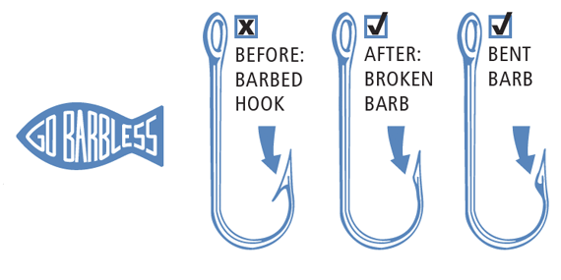

Hooks are attached to a line. Sometimes there is a mechanical device between the hook and the line called a swivel which keeps the line from getting twisted as the hook is pulled through the water. If the fish you are trying to catch are large and toothy, you may put a piece of steel wire called a leader between the hook and the line to protect it. Swivels and leaders are terminal tackle. Terminal tackle are the pieces of a fishing line/hook setup that don’t actually catch fish. They include swivels, weights, steel leaders, etc. Lures generally mimic wounded baitfish, or replicate small baitfish which are part of a fish’s usual diet. Fly fishermen create life sized replicas of flies, bugs and larvae which they use to replicate the food source of trout. These lures are referred to as flies and are seen as an art form by many fishermen.

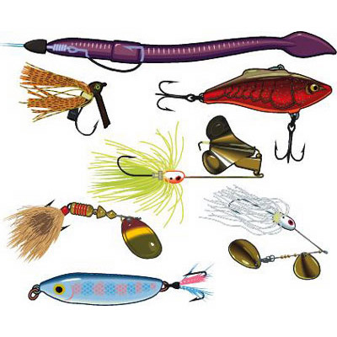“Back in the day”, fishing line was as simple as string. Today, modern fishing lines are commonly highly technical, carefully designed materials which claim to have a wide variety of characteristics. Some lines claim to be invisible in water, and others claim high visibility to aid in casting. Some claim no stretch, while others are proud of the amount of stretch they have. Lines come in every color, diameter, and characteristic you can think of. They also come in every price range. Basically, a person needs a type of line which suits the fishing they are doing and that can handle the fish they may catch. Lines are measured in “pounds test” or the weight that can be applied to the line before it breaks. If you are fishing for rainbow trout at a stocked pond, you can easily use a smaller, lighter line like a 4 or 6 pound test. If you are fishing deep water for lake trout that can exceed 20kg, you need a stronger line. Lines used by fly fishermen are unique creations which can float, sink, or float and sink, depending on what is desired.

The rod and reel are what brings everything together. Rods are available in a variety of materials and flexibilities, known as action. People who are fishing from a moving boat – known as trolling – prefer stiff rods (fast or heavy action) which can handle consistent pull. Fly fishermen prefer long rods with lots of flex and whip which will enable them to get their tiny flies to targets up to 20m away. Ice fishermen like short rods with lots of flex (light action) because they are often fishing right over a hole, or from within a shelter. The reel is where the line is stored and how the line is pulled in. Cranking the handle on a reel operates a set of gears which speeds up the retrieval of the line. There is also a mechanical brake, called a drag, which allows the fish to pull line out at a controlled rate. This is necessary when fighting large fish. If there was no opportunity for fish to take line, the breaking strength of the line would automatically give out when the limit was reached. There are different kinds of reels, each of which is designed for specific kinds of fishing, but can generally be used for all kinds. These include open faced spinning, closed faced spinning, and bait casting.

Every person who takes up fishing is going to need somewhere to keep their stuff. These units are called “tackle boxes”. If a person only had one hook all they would need is a container to keep that hook in. Most fishermen, however, are equipped with a variety of hooks for a variety of conditions to fish for a variety of species. The tackle box can also hold other important pieces of equipment and supplies that fishermen may need, such as pliers, clippers and bug spray. This box should also have a survival kit and first aid kit – just in case things don’t go as planned.

Once the basic gear is acquired, there are lots of optional things that can be added to the collection. Fly fishermen wear waders to walk into the streams, or use belly boats or small personal human powered watercraft to access small ponds and lakes. Many fishermen have boats that they fish from. These could range from a simple canoe or rubber dingy to giant vehicles with multiple hundred horsepower engines, reclining chairs, sonar, refrigerators, and bathrooms. TV cameras are available to fishermen who want to see what is going on below and a variety of fish locating devices are available for both boat, shore and ice fishermen.

HARD WATER ANGLING

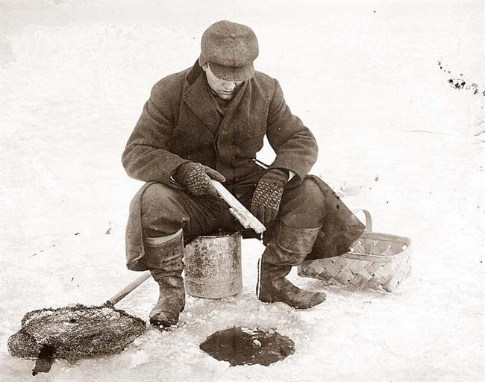Watch the video “Giant Lake Trout Ice Fishing” (P8)

Hard water angling, also known as ice fishing, provides fishermen with a unique fishing opportunity. Many people who don’t own boats find it difficult to reach all parts of a water body during the summer. When winter comes and the ice is thick, they have access to the lake as far as their feet or transportation will take them. The only specialized equipment needed is a way to cut a hole in the ice, usually an ice auger.

Ice fishing is done through a hole in the ice that is usually between 10 and 30cm in diameter. The fisherman drills the hole in a likely location, drops a hook with bait or lure down the hole, and waits for a bite. Weather can affect ice fishing, so many ice fishermen have portable ice shacks or shelters to protect them from the weather. Some shelters are simple pop-up affairs which can be carried quite easily. Others are more like trailers which have to be moved by trucks or snowmobiles. An added benefit to having a shelter is that if it is dark inside, it allows the fisherman to look down the hole and often see many feet into the water.

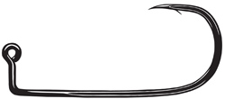The technique used for ice fishing is called jigging. Jigging is any type of fishing done in a vertical manner. A lure or hook is dropped into the water and then occasionally lifted to simulate a wounded baitfish, or just to give movement to attract fish. Hooks used for jigging are often made in such a way that when a fish takes the hook, it will catch the top lip more easily.

Ice fishing is a great activity to do with children because there can be so much more to do than fish. Sledding, building forts, having a campfire on the ice, and just playing in the snow make the waiting so common to fishing more bearable. Alberta allows ice fishermen to have two lines in the water at once, so many fishermen take advantage of this and utilize tip ups. These semi-mechanical inventions allow fish to trigger a flag or bell when they bite, so when a fish is on the hook, children and fishermen are drawn immediately to the hole to see what is on. There are many types and designs for tip ups and they can add to a fun experience on the ice.

OPEN WATER ANGLING

Open water angling takes place on a lake, river or stream when the ice isn’t present. One major division in open water angling is between the boat fishermen and the non-boat fishermen. People fishing from shore are limited to the part of the lake they can cast to, whereas boaters have access to as much of the lake as they can safely access. Shore fishing is a very inexpensive and relaxing activity. These fishermen tend to use bait suspended under a bobber, or float, and wait for a bite to take place. A bite can be indicated by a bell, a disappearing bobber, the bouncing of the rod tip, or some people even have electronic sensors to get their attention.

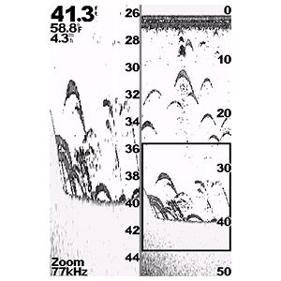Boat fishing allows fishermen to cast lures to possible hiding spots, jig bait over cover or suspended fish, or troll over and along promising structure. Electronics have become important to many fishermen, not to tell them where the fish are, but to indicate places where fish are likely to be. Structure is the dips and shallows of the lake or river bottom that provide attractive water temperatures, shelter and food for fish. Trolling allows fishermen to slowly drive the boat over these spots while pulling lures or baits behind the boat. Speed is very important when trolling – the boat should only go as fast as the bait would naturally go. Too fast, and the fish can’t catch up or don’t have enough time to see it. The image at right is an example of a fish finder screen.

Watch “Flycasting for Beginners” (P9)

Fly fishermen generally consider themselves the artists of fishermen. Fishing using a tiny fly tied to a hair-thin tippet on a weighted line controlled with a bendy rod nearly 3m long requires lots of practices. Especially when the species being targeted is trout and they are very perceptible to sound, movement and noise. Accuracy is very important to fly fishermen because they are often “sight fishing” which means they watch for a fish to suck a bug of the surface, then cast to that exact spot, even when that spot can be 15m or more away and under a tree branch!

CARE OF YOU CATCH **(P10)**

There are a few different things you can do with your fish once you have it in hand. If you are going to release it, do so quickly and with as little handling of the fish as possible. Fish are covered with a slime that acts as a protective layer and too much handling can remove the slime and make the fish more vulnerable to disease and bacteria. If you catch a fish that is especially large, or special in some way, and you want to have it mounted, there are two ways to go about it. If you are going to have a taxidermy mount made (get it stuffed), you need to kill the fish without damaging the skin, freeze it and get it to the taxidermist as soon as possible. Fish that are mounted are not eaten, nor is the meat used in any way. The current cost to have a fish mounted is about $5 to $10 per centimeter. Fiberglass replicas are also an option which have some added benefits. A replica can be made of a fish as long as there are pictures and measurements taken. After that is done, the fish can be released, or kept and eaten. The price for a replica varies, but is quite similar to a real mount.

Watch “How to Clean Trout with Scissors”. (this is actual video of a real fish being cut open and skinned.) Read Preparing and Cooking Your Catch in the text

C:\Documents and Settings\Kelly.Lewis\Local Settings\Temporary Internet Files\Content.IE5\TL9T46E7\MC900413020[1].wmfFish that is going to be eaten, however, can be kept in one of two ways. Some people prefer to keep their fish alive in a fish basket on the side of the boat, or in a live well in the boat. Most, however, prefer to kill their fish and get it cooled as soon as possible. Putting the fish on ice in a cooler is an excellent way of keeping the fish cool. When fish gets warm, it gets mushy and looses much of its appeal on the fork. Many people also bleed their fish to ensure the meat stays as white as possible. There are many different methods to prepare your fish, once you get back to camp, but the most common are filleting, steaking or baking whole. Some people even enjoy canning their fish for consumption up to months later, but freezing fish tends to take away from the taste and texture and frozen fish lasts only a matter of weeks in top shape.

FISHING SAFETY Read the Safety chapter in your text

Just like any activity, there are safety precautions which must be taken when fishing. There are obvious ones, of course, like a life jacket when you are in a boat, but there are some others that aren’t so obvious.

Every year thousands of fishermen get a hook stuck in some part of their body. If they are lucky, it is only a finger or an ear. If they are unlucky, it could be their eye. Every year people pull hard on their fishing line and yank the hook right out of the fish’s mouth and send it flying through the air at great speed. If they are lucky, it flies harmlessly through the air. If they are unlucky, the hook could easily get caught in their eye. A very simple precaution is to wear glasses while fishing. They don’t have to be special glasses – even sun glasses will usually offer enough protection from a hook – as long as they are on your face. Many fishing guides demand that their fishermen wear glasses for this very reason. It is more common to get a hook in a finger or other body part, but no less painful. Although accidents can’t be prevented, it is always good practice to learn your limitations and work your hook and line in such a way as to minimize chances of loose hooks finding human flesh instead of fish flesh.

Watch the “Ice Safety Videos” on The Buddy System, Ice Thickness, Unsafe Ice Fishing Conditions, Test Holes and Safety Spikes. **P11**

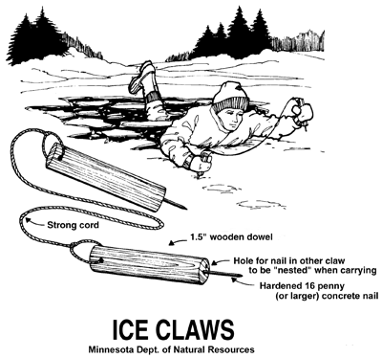Ice fishing requires some special safety precautions. Did you know the only place in Alberta that you can drive without your seatbelt is on a frozen lake? It is recommended that you drive with your belt off and your window down when crossing a frozen lake. This is solely to allow for a quick exit if your vehicle should break through. If you are walking on ice and break through, having a pair of ice claws will help you get out of the water and back onto the ice.

One of the easiest safety precautions you can take is making sure someone knows where you are going, and when you expect to be coming home. If you happen to be fishing by yourself and there is an accident, it is good to know that someone will be looking for you if you don’t show up by an appointed time. Not all wilderness areas have cellular service, so phoning isn’t always an option. Leave a plan with someone, or in an obvious place so people will know where to look for you.

First aid training is a valuable skill to have at all times and in all places. Accidents cannot always be avoided, but the timely treatment of any injuries can mean the difference between life and death.